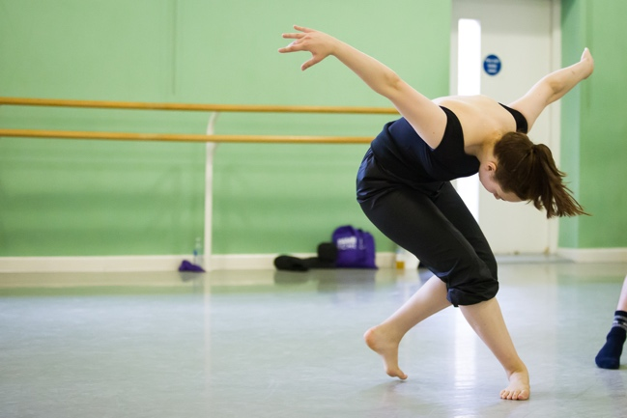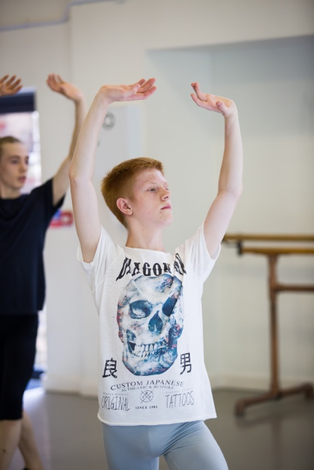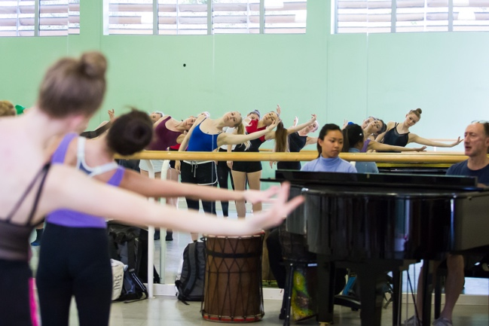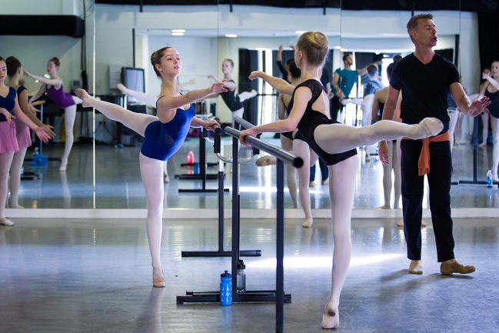

Autumn Intensive 2021

14-19 YEARS

Monday 25th – Wednesday 27th October 2021

Course Fee: £195

**About the course**

Rambert School Autumn Intensive 2021 offers aspiring dancers the chance to take part in a 3-day intensive training programme designed to deepen technical understanding and support creative expression, helping to prepare ahead of vocational auditions.

Delivered by faculty, alumni and associated artists of Rambert School, participants are given the opportunity to immerse themselves in the professional training world and given insight into the audition room. Through a daily class schedule, students will expand their technical awareness, develop their creative response and discuss audition and interview techniques to support them through the process, whilst maintaining their individual voice.

**Typical day**

Students will take daily ballet and contemporary technique classes, complimented by sessions in pointe, ballet repertoire, conditioning, improvisation and creative work underpinning the School’s 50/50 focus on ballet and contemporary. Additional sessions delivered are musicality and audition and interview technique, solo support and the chance to ask Rambert School staff and students questions about vocational training and beyond.

**Faculty**

Classes will be led by Rambert School’s faculty and alumni as well as guest teachers, with technique classes accompanied by live musicians.

**Requirements**

Students must be at least 14 years (in school Year 10+) and be planning on auditioning for full-time vocational dance training.

Students should have been attending weekly dance classes for **at least two years** and be dancing at an intermediate level or above.

**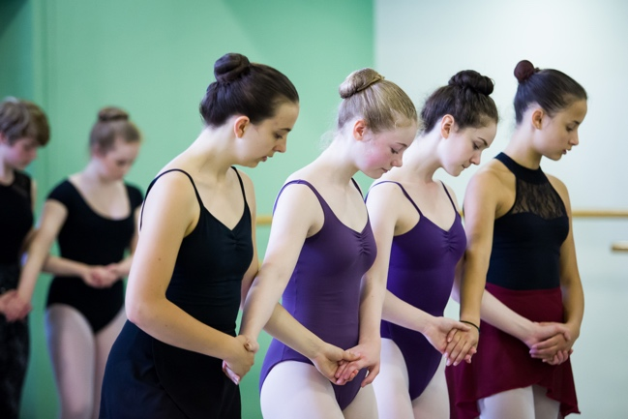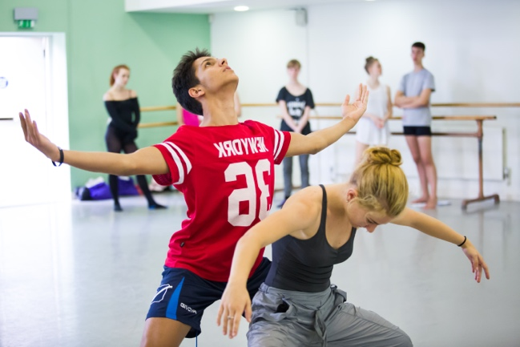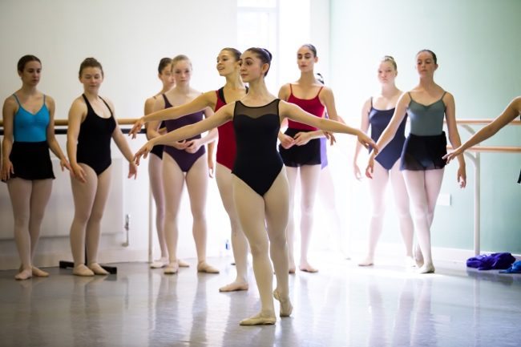***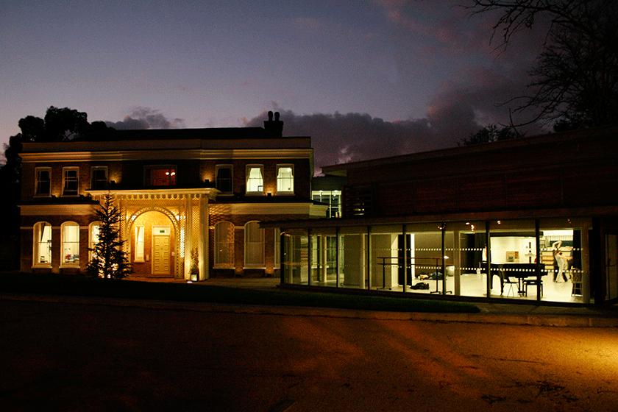All photos: Nicole Guarino*

**How to Apply**

Complete and submit the online application form

Applications will be accepted until 15th October 2021, or until all places are filled. Places will be offered to students meeting the requirements on a first-come-first-serve basis.

**Payment**

The course fee is to be paid in full upon acceptance of a place. Successful applicants are not confirmed a place on the course until payment has been received. If you are offered a place on the course, you will have one month from the offer date to send payment before your place is released.

A limited number of bursaries will be available to UK residents. Please indicate on the application form if you are interested in applying for a bursary and your household income is less than £42,875.

**Cancellation & Refund Policy**

The course fee includes a £70 non-refundable deposit. If the place is cancelled up to one month before the start of the course, a refund of the remaining £125 will be issued. If the place is cancelled with less than one month’s notice (after 25th September), no refund will be issued.

**Location**

The Autumn Intensive will be held at Rambert School:

Clifton Lodge, St. Margaret’s Drive, Twickenham, TW1 1QN

**Accommodation**

The Autumn Intensive is a non-residential course. If needed, accommodation should be arranged by students. A list of local hotel options is available on the website.