Rambert School takes its responsibilities to students, staff, visitors and the local community, extremely seriously. The wellbeing, health and safety of our community has been central to our planning. This Outbreak Management Plan sets out a framework for dealing with one or more cases of Covid-19 amongst the School community.
The School
Rambert School has a population of 140 students and 34 staff. The site is located in St Margarets and is split across two buildings either side of Kilmory Drive. In previous years most students and some staff use buses and other forms of public transport to commute to the School. There is no accommodation on site with students living in flat shares or homestays in the local area. There are a number of staff that live in the local area to the School but a number also commute across London.
In response to the Covid-19 pandemic, the School reduced activities to all but essential work on March 23rd, 2020. All teaching, assessment and support migrated to online provision and most staff have been supported to work from home or furloughed. In June 2020 the School introduced a small number of tester classes in line with Sport England guidelines for 30 students split into smaller groups. From September 2020, the School has offered a blended learning approach i.e. online digital and in-person face to face teaching. Students who are not able to attend on campus are supported to study from home. Some School staff are working on site, others from home but the majority will be working in a flexible / hybrid way (working from home but also on campus on occasions where required) until at least Christmas 2020. Key operational measures have been implemented for the academic year to ensure the ongoing safety of students and staff.
This Plan
This Plan is a living document and updated regularly. We will publish this plan on our website so that it is publicly available. The School is actively working with key stakeholders, to regularly review this Plan and its implementation in response to the evolving public health situation. We will always be guided by national guidance, the Public Health England’s (PHE) Health Protection Team (HPT) and the local authority’s Public Health Team. The HPT will provide guidance to the School on how we should respond to positive cases amongst students and staff and their contacts, both within the School community and wider area. The School is mindful that this is a stressful time for all members of the School and our local community. It is an important principle that all members of the School should be kind, sensitive and supportive of each other, recognising that the impact of the pandemic can be very different for individuals, their families and friends. Talking about its impact on us can also be difficult, and we will ensure that our conversations respect individuals’ diverse personal circumstances. We will support each other and call upon professional advisers and services as appropriate to support the physical and mental health of all impacted by coronavirus. The School has duties of care towards staff, students and visitors, including under the Health and Safety at Work etc. Act 1974 and the Equality Act 2010. The School will continue to comply with those obligations. The Head of Technical Theatre and Maintenance has responsibility for the updating, implementation and evaluation of this Plan.
Aims
- To ensure that Rambert School continues to provide high quality services whilst providing a safe working and studying environment for staff and students
- To aid the prevention and mitigation of the spread of Covid-19 cases through effective engagement with our community on Government, public health and School rules
- To support the health and wellbeing of students and staff who become infected, and their contacts, in line with current Government guidance.
- To prepare for any community or school outbreak in partnership with NHS and PHE
- To support staff and students beyond immediate outbreak control (health and wellbeing, equality, diversity, and inclusion).
- To identify strategic ownership and leadership of the School Outbreak Management Plan and clear escalation protocols
- To ensure the School’s Outbreak plan is in line with the Richmond Outbreak Plan

1 | Prevention | Ensure student, staff and visitor safety by implementing and regularly reviewing measures that prevent the spread of Covid-19 among students and staff in line with Government guidelines
2 | Identification and management | Implement protocols to respond effectively to Covid-positive diagnoses among students and staff that enable rapid identification of individuals affected, mitigate the spread of Covid-19 and respond quickly to any emerging outbreaks.
3 | High risk contexts and individuals | Identify and manage high risk School locations, individuals and situations to minimise risks and impacts.
4 | Quarantine and isolation | Provide clear information and advice to students and staff living in the community, providing practical support (eg food and medicines) and wellbeing.
5 | Testing | Enable timely testing of affected individuals and any contacts in accordance with NHS and PHE protocols
6 | Contact tracing | Integrate School information sources, such as studio booking information to facilitate data sharing with PHE and HPT to identify close contacts of someone with a positive Covid diagnosis. [Sharing such information about Covid overrides GDPR.]
7 | Wellbeing | Support vulnerable members of the School community by ensuring access to high quality mental health, emotional support and practical assistance as required.  Use Equality Impact Assessments to determine and address any differential impacts across the School community.
8 | Data Collection and management | Data collection: Consider implementing secure data management systems to keep a record of who is a confirmed case and information relevant to contact tracing (held as special category data for legitimate specified purposes)  Ensure that staff recognise the sensitive personal nature of this information and that it is collected ethically and securely, with the appropriate governance, regulatory and security measures in place.
9 | Communication and engagement | Ensure students and staff are kept informed and up to date with Government guidance and University plans and rules  Ensure students and staff understand their responsibilities, including how these are vital to everyone’s safety and wellbeing.  Encourage expected behaviours at all times and make clear the consequences of unsafe behaviours  Maintain effective working relationships and actively work with key stakeholders within PHE, R&W HPT, NHS, R&W Council and other HE providers in the area to prepare for and manage any community or school outbreak

Scenarios
This Plan outlines four scenarios, mapped to the 9 themes above, but we will take into consideration variations within these such as in accommodation type, additional health care needs or vulnerabilities. For each scenario, responsibility for actions will be assigned to an individual; clear action plans and procedures developed; communication plans drafted and post incident reviews arranged.
1. Student or staff member is unwell with Covid symptoms, but Covid-19 not confirmed.
2. Confirmed diagnosis of Covid-19 on Rambert School Site, either a single identified diagnosis of COVID-19 or a localised outbreak in student accommodation, faculty or department.
3. Multiple diagnoses of Covid-19 including a large-scale outbreak that may result in substantial restrictions implemented at a local level that impact on the activities of the School
4. Increased prevalence of infection locally that requires interventions on the whole community, including students and staff.

Scenario 1: Student or staff member is unwell with Covid symptoms, but Covid-19 not confirmed.
1 Prevention | 2. Identification & management | 3. High risk contexts/individuals | 4. Quarantine and Isolation | 5. Testing | 6. Contact tracing | 7. Wellbeing, | 8. Data collection | 9. Communication and Engagement
Follow national guidance and mitigation measures  Complete risk assessments and implement mitigations  Inform students and staff about expected behaviours and the consequence of not behaving in this way  Provide frontline staff with information on how to protect themselves and residents from Covid spread  Ensure clear signposting to NHS Test & Trace and other services  Any misconduct will be dealt with through the discipline escalation protocol | Provide clear guidance to all staff on what to do if told by a student they are ill (stay home, self isolate, get a test)  Encourage student(s) and staff to report to the head of STRU that they are symptomatic / self isolating and to confirm test outcome:  Request individuals inform Test and Trace that they are a School student/staff member and communicate the results of Covid test to the head of STRU asap  Encourage line managers to keep in touch with people who are isolating and confirm test results with the head of STRU. | Provide advice on how to avoid spreading coronavirus to people you live with  Review all risk assessments for high risk individuals and situations and ensure that any additional measures are implemented.  Ensure that frontline staff are aware of all protocols and any particular risks are mitigated  Students asked to identify any particular needs or vulnerabilities prior to academic year and subsequently.  Risk assessments undertaken as required, mitigation measures implemented and support provided.  Individual risk assessments completed for staff following discussion with their line manager. | Provide government guidance on what to do if symptomatic  Ensure any students and staff required to self-isolate have access to guidance. and support.  Ensure household contacts of symptomatic person self-isolate as per guidance  Provide clear information to students and staff about the School reporting line and the importance of reporting  Ensure that all procedures align with Government Test and Trace guidance | Ensure all students and staff are aware of how they can access testing when symptomatic by providing Government advice on getting to a test centre or ordering a home kit if needed  Provide government guidance on what to do if test returns as positive (see below).  Provide support to access testing  Testing of contacts is not necessary unless the contacts develop symptoms of Covid-19 | Encourage people who test positive to provide requested information to NHS Test and Trace  Provide additional information as requested by NHS T&T to augment conventional contact tracing with School information, e.g. timetables  Support contacts who are students/staff to isolate for the required amount of time  NHS Test & Trace will assist with notifying affected people. | Student Support will check-in regularly with isolating students  Support with access to food and medicine if required  Provide guidance and wellbeing support for contacts to follow PHE guidance  Managers will check-in with isolating staff regularly  Consider access to education and support for isolating students particularly those with additional vulnerabilities | Use secure systems to safely manage and store records of confirmed cases and information relevant to contact tracing (held as special category data for legitimate specified purposes). | Reinforce ‘Be Safe’ campaign messages, including advice on ‘Isolate, Test, Tell’. Ensure timely updates & guidance are distributed to all key stakeholders Ensure that all comms channels contain current information and guidance

Scenario 2: Confirmed diagnosis of Covid-19, either a single identified diagnosis of Covid-19 or a localised outbreak in student accommodation, faculty or department.
1 Prevention | 2. Identification & management | 3. High risk contexts/individuals | 4. Quarantine and Isolation | 5. Testing | 6. Contact tracing | 7. Wellbeing, | 8. Data collection | 9. Communication and Engagement
As above  Regularly encourage students and staff to follow School guidance and information sources reinforced  Clean rooms and other facilities following guidance on cleaning non healthcare settings.  Accommodation that has been vacant for over 72 hours will need standard, but thorough, household cleaning  Convene post incident reviews following incidents to collate learnings for continuous improvement | Follow notification pathway based on national/local guidance and encourage student(s) and staff to report to the head of STRU that they have a positive test result  Notify LCRC if a student or staff member has a positive diagnosis and inform the Council’s public health team.  Anyone with a Covid diagnosis, symptoms and/or are household or support bubble contacts of possible, or confirmed cases are required to self-isolate for the required amount of time.  In the event of a confirmed case the School will close and all staff and students will be required to isolate for the required amount of time.  LCRC will inform the School and in agreement with the local authority’s Public Health Team will agree when the number of cases warrants an Outbreak Control Meeting with the school which will provide guidance and mange outbreak response  Case management team will coordinate information flow, support arrangements and contact key support functions – maintenance, cleaning, timetabling etc. as required.  School Covid Team will work with HPT to determine any additional measures.  Students who experience any medical issues (alongside Covid symptoms) will be triaged. | .Follow current guidance on protecting people who are clinically extremely vulnerable:  If an infected student, staff member or a contact, lives with someone at higher risk from coronavirus, signpost to Government advice on avoiding spreading coronavirus to cohabitees.  Review all risk assessments for high risk individuals and situations and ensure that any additional measures are implemented. | Inform individual on Government guidance for self-isolation and treatment  Support welfare of those isolating & any housemates.  Advise that they monitor for worsening symptoms; provide details of support contacts.  Any student who is a close contact to follow PHE instructions.  Students / staff taking care of, sharing accommodation with a person with Covid19, follow instructions from PHE on when to return to campus.  Follow Government cleaning guidance where students have Covid-19 in student accommodation. | As Above | Encourage people who test positive to provide requested information to NHS Test and Trace  Provide additional information as requested by NHS T&T to augment conventional contact tracing with the school information, e.g. timetables  Support contacts who are students/staff to isolate for the required amount of time  NHS Test & Trace will assist with notifying affected people. | Student Support will check-in regularly with isolating students  Support with access to food and medicine if required  Provide guidance and wellbeing support for contacts to follow PHE guidance  Managers will check-in with isolating staff regularly  Consider access to education and support for isolating students particularly those with additional vulnerabilities | Use secure systems to safely manage and store records of confirmed cases and information relevant to contact tracing (held as special category data for legitimate specified purposes). | Reinforce ‘Be Safe’ campaign messages, including advice on ‘Isolate, Test, Tell’.  Ensure timely updates & guidance are distributed to all key stakeholders  Ensure that all comms channels contain current information and guidance

Scenario 3: Multiple diagnoses of Covid-19 including a large-scale outbreak at the institution that may result in substantial restrictions implemented at a local level that impact on the activities of the school.

1 Prevention | 2. Identification &  management | 3. High risk contexts/individuals | 4. Isolation | 5. Testing | 6. Contact tracing | 7. Wellbeing, | 8. Data collection | 9. Communication and Engagement
As above  Monitor local transmission rates through data on Covid-19 indicators in different parts of the country  Review the Covid-19 contain framework which sets out how national and local partners will work together to prevent, contain and manage local outbreaks.  Unless advised otherwise, in the event of additional restrictions being imposed locally during term, students will remain in their current accommodation and not return to the family home | Definition of an outbreak  PHE HPT will inform the School and in agreement with the local authority’s Public Health Team will arrange an Outbreak Control Team meeting with the school which will provide guidance and mange outbreak response  The HPT/CHPT will undertake a risk assessment and provide appropriate support and guidance.  In such a situation, restrictions will be implemented in a phased manner - the key aim being to retain face-to-face provision where it is possible to do so safely.  In the event of a possible outbreak on site, refer to the Joint Biosecurity Centre (JBC)’s action cards that relate to managing possible outbreaks in education settings  Implement business continuity plans to enable core operations to continue despite staff absences | As above  Consider any additional information that may be needed to inform and reassure high risk individuals and those in high risk situations | As above | LCRC to advise on available testing and if a Mobile Testing Unit is required.  MTUs can be deployed with 12 hours’ notice, so would be available the following day. The current process around requesting support from MTU is awaiting confirmation, however all requests for support can be sent to emergencyplanning@ richmondandwandsworth.gov.uk | HPT will lead on notifying affected people. | As above plus:  Student wellbeing comms around anxiety – encourage students to contact Student Support  Brief contracted service providers to ensure consistency of support/messaging | As above | LCRC to lead on reactive comms in partnership with local authority and Rambert School’s Covid Team and assist with Rambert School internal assets.  Ensure timely updates & guidance are distributed to all key stakeholders across our channels including our website.  Incident Management Team to be convened by LCRC with the School Covid Team (Amanda Britton, Peter Dunleavy, Judy Bowden, and Jonathan Aloia) and Richmond Public Health.

Scenario 4: Increased prevalence of infection locally that requires interventions on the whole community, including students and staff.
Prevention | 2. Identification &  management | 3. High risk contexts/individuals | 4. Isolation | 5. Testing | 6. Contact tracing | 7. Wellbeing | 8. Data collection | 9. Communication and Engagement
As above  Monitor local transmission rates through data on Covid-19 indicators in different parts of the country  Review the Covid-19 contain framework which sets out how national and local partners will work together to prevent, contain and manage local outbreaks.  Unless advised otherwise, in the event of additional restrictions being imposed locally during term, students will remain in their current accommodation and not return to the family home | As above plus:  Mitigation strategies will extend across organizations (e.g., schools, business, community organizations) within the community.  Local authority public health team with HPT will provide guidance and lead with local outbreak mitigation measures.  Initiate all emergency management and business continuity protocols. | As above | As above | As above | As above | As above plus:  Consider wellbeing and mental health needs of broader student and staff populations affected | As above | LCRC and PHE to advise with reactive comms and any additional guidance  Ensure timely updates & guidance are distributed to all key stakeholders across our channels including our website

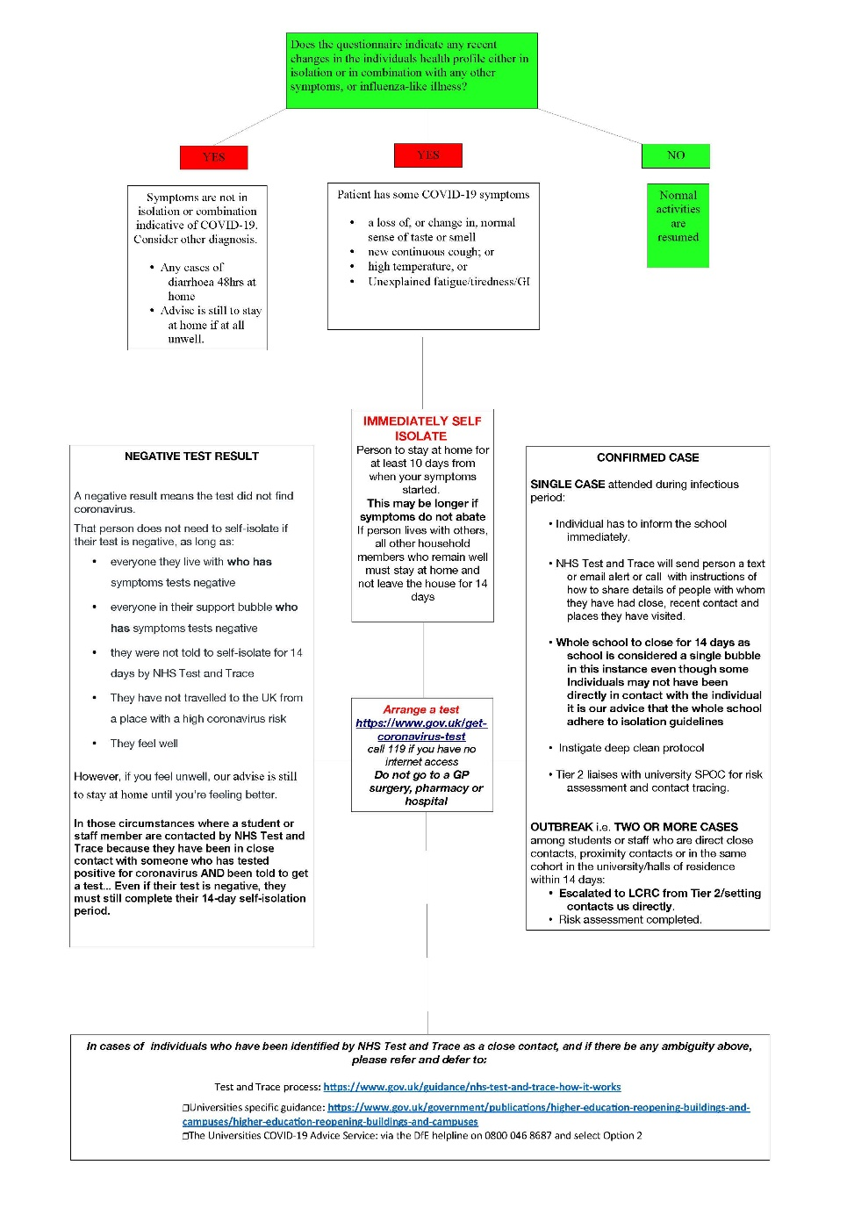
Appendix 1: Rambert School Covid 19 Flow Chart

Appendix 2: National Guidance and Glossary

Covid-19 diagnostic definition
See government guidance on case definitions.
Definition of contacts See government guidance: What do we mean by a contact.
Government guidance
- Higher education coronavirus (COVID-19) NHS Test and Trace handbook
- Government guidance on re-opening campus, in particular what the Government expects that HE providers will consider: https://www.gov.uk/government/publications/higher-education-reopening-buildings-and-campuses/higher-education-reopening-buildings-and-campuses This advice refers to providers duties of care towards staff, students, and visitors, including under the Health and Safety at Work Act 1974 and the Equality Act 2010.
- Guidance for isolation in residential education settings:

https://www.gov.uk/government/publications/coronavirus-covid-19-guidance-on-isolationfor-residential-educational-settings/coronavirus-covid-19-guidance-on-isolation-forresidential-educational-settings.
Guidance on the NHS test and trace service for employers, businesses and workers: https://www.gov.uk/guidance/nhs-test-and-trace-workplace-guidance.
Data sources for symptoms
https://covid.joinzoe.com/post/covid-clusters
https://covid.joinzoe.com/post/early-covid-signs

Other local and national guidance
- Guidance from Universities UK at: https://www.universitiesuk.ac.uk/covid19.
- NHS information and advice: https://www.nhs.uk/conditions/coronavirus-covid-19/

Universities COVID-19 Advice Service
- A new universities advice line has been set up to provide advice to designated university coronavirus leads around managing uncomplicated single lab confirmed cases, including staff and students who live in halls of residence or the wider community in private rented or family accommodation. As universities may have several unlinked ‘single’ cases the service will provide advice on the process for each individual case. This PHE advice service is available to universities via the DfE helpline on 0800 046 8687 and select Option 2. The service is open 8am – 6pm Monday to Friday and 10am – 4pm Saturday and Sunday.

Appendix 3: Rambert School Covid Team

Main Number- 02088929960
Amanda Britton (Principal)- Amanda.britton@rambertschool.org.uk
Jonathan Aloia- jon.aloia@rambertschool.org.uk
Peter Dunleavy- peter.dunleavy@rambertschool.org.uk

