ACCOMMODATION OPTIONS

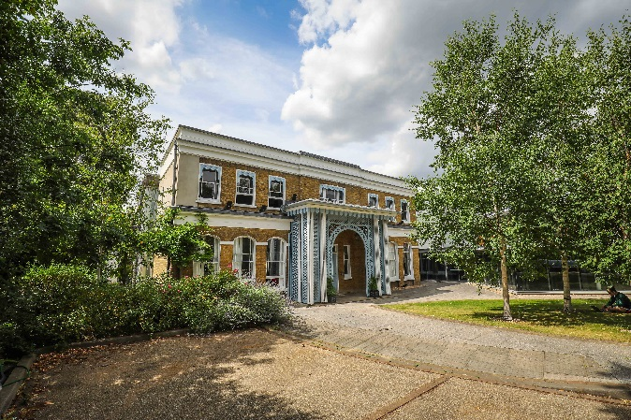
Rambert School Summer Course is non-residential. Where necessary, students (or parents/carers) are responsible for arranging their own accommodation, as well as travel to and from Rambert School.
McKenna Homestay
A local company can arrange for students to stay with a host family for the week. For more information please contact Christine McKenna at mckennashomestay@btinternet.com or call +44 (0)208 898 9558.
Alternatively, there are several local hotels or hostels that can be booked online.
Hotel | Address | Cost /night | Walking  Time |  | Travel |  | Website
The Old Stables  (B’n’B) | 1 Bridle Lane, St Margarets  Twickenham  TW1 3EG | From £82 per room | 10 mins | H37 bus (St Margarets Station to St Margarets Drive) |  | BOOK
Travelodge | London Road  Twickenham  TW1 3SQ | from £53 | 25 mins |  |  | BOOK
Travelodge Richmond | 9 Paradise Road  Richmond  TW9 1RX | from £58 | 20 mins | H37 bus (Richmond to St Margarets Drive) |  | BOOK
Premier Inn (Twickenham Stadium) | 416 Chertsey Road  Whitton  TW2 6LS | From £55 | 45 mins | Whitton Station (regular trains to St. Margaret’s) |  | BOOK
Marriot Hotel Twickenham | 198 Whitton Road  Whitton  TW2 7BA | from £169 | 25 mins |  |  | BOOK
Richmond Hill Hotel | 144-150 Richmond Hill  Richmond  TW10 6RW | from £129 | 30 mins | H37 bus (Richmond to St. Margaret’s Drive) |  | BOOK
Earls Court Hostels | There are many hostel options in the Earls Court area, easily connected to Richmond by London Underground District Line. Check Earls Court YHA or Hostel World.com.

