Junior Summer Course
11-14 years
Monday 24th July – Saturday 29th July 2017
Course Fee: £375
Applications will be accepted until 31st May 2017, or until all places are filled. Places will be offered to students meeting the requirements on a first-come-first-serve basis.
PLEASE UPLOAD HEADSHOT
Please insert headshot

Please complete all sections, save in .doc, .docx, or .pdf format and return your completed application to: emili.astrom@rambertschool.org.uk with subject line: Junior Summer Course 2017 App STUDENT NAME.
Note for Mac users: If you are completing the application form using a Mac please convert the document to a Word doc or PDF as we are unable to accept Pages docs.
Please include all requested photos (headshot plus one in each pose regardless of gender: 3 photos in total)

PERSONAL DETAILS
Surname Click here to enter text. | Name(s) Click here to enter text.
Date of Birth (dd/mm/yy) Click here to enter a date. | I identify my gender as Click here to enter text.

Email Address Click here to enter text.  Please note, this email will be used for all correspondence | Main Contact Number Click here to enter text.  Secondary Contact Number Click here to enter text.

Address Click here to enter text. | Postcode Click here to enter text.

Nationality Click here to enter text. | Country of Residence Click here to enter text.

How did you hear about this course?
Internet Search ☐ Dance Teacher ☐ Rambert Company ☐ Friend Recommendation ☐
Rambert School Workshop/Performance ☐ Current Student ☐ Rambert Graduate ☐ Rambert School Website ☐
Attended Summer Course 2016 ☐ Facebook ☐ Other social media (please state) Click here to enter text.
Magazine Advertisement ☐ Careers Advisor/School ☐ Other (please state) Click here to enter text.

EDUCATION, DANCE EXPERIENCE AND TRAINING
Current/most recent primary/secondary schoolClick here to enter text.
BALLET TRAINING
Name of school Click here to enter text.
Main Teacher’s Name Click here to enter text. | Teacher’s Email Address Click here to enter text.
Number of continuous years studied: Click here to enter text.
Last ballet exam (syllabus, level, grade):Click here to enter text.
Number of years en pointe: Click here to enter text.
Please note, pointe is not a requirement for acceptance on the course.
Please give a short paragraph of your classical ballet experience, if any, including, number of continuous years studied, technique/style studied and courses/classes attended.
Click here to enter text.
CONTEMPORARY TRAINING (if different school/teacher from above)
Name of school Click here to enter text.
Main Teacher’s Name Click here to enter text. | Teacher’s Email Address Click here to enter text.
Number of continuous years studied: Click here to enter text.
Please give a short paragraph of your contemporary dance experience, if any, including technique/style studied, courses/classes attended and exams you have passed.
Click here to enter text.

PERSONAL STATEMENT
Please use this page to tell us about your achievements, ambitions and inspirations, and why you would like to take part in this course at Rambert School.
Click here to enter text.

Please upload one photograph in dance practice clothes (so the lines of your body are clearly seen) of a ballet pose and a contemporary pose. Examples poses are below, alternative poses can also be submitted. NB: please submit each pose regardless of your gender.

EXAMPLE BALLET POSES EXAMPLE CONTEMPORARY POSES
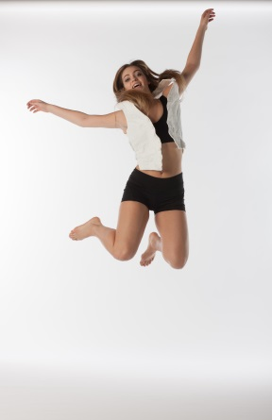
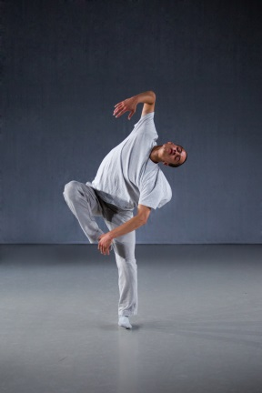

DANCE PHOTOS
Ballet Pose
Contemporary Pose

You can insert a picture that is saved to on your computer/desktop by clicking the picture in the centre of each pose box.

ENCOURAGEMENT TO DISCLOSE
Rambert School of Ballet and Contemporary Dance welcomes applications from disabled people and offers places solely on the basis of potential and suitability for a career in the profession. You are encouraged to disclose any impairment or condition (for example, dyslexia, mental health, a physical, sensory impairment) at the earliest opportunity. We can then endeavour to support you during the course.
Applicants should be reassured that any information you disclose is so that we can support you during the application process.
Please include details here Click here to enter text.
INJURY
Our courses are rigorous and require high levels of energy and commitment. It would be very helpful if you could let us know if you have any performance related injuries or health difficulties, for example bone or joint problems, or if you are currently taking prescription drugs of any kind.
Please include details here Click here to enter text.
CARE LEAVER
Guidance note: The Children (Leaving Care) Act 2000 states that a Care Leaver is someone who has been in the care of the Local Authority for a period of 13 weeks or more spanning their 16th birthday. We ask for this information to ensure that eligible students receive available Care Leaver funding and additional support.
Are you a care leaver? Y ☐ N☐

DECLARATION
I declare that to the best of my knowledge all information given in this application is true, accurate and complete. Writing your name below will count as your e-signature.
Signature of Applicant Click here to enter text. | Date
Signature of Parent/Guardian Click here to enter text. | Date

If you have any queries about completing this application form please contact the school on:
+44 (0) 20 8892 9960
emili.astrom@rambertschool.org.uk

If you are a UK resident interested in applying for a bursary to cover part of the course fee, and your (joint) household income is less than £42,500 please tick this box to receive more information. ☐

Please complete The Equality and Diversity Information on the next page. This will not be used as part of your application.

Equality and Diversity Information
Please complete the following monitoring information.

Rambert School of Ballet and Contemporary Dance welcome applications from all sections of the community regardless of ethnicity, age, gender, religion or disability. The information you give in this section is used for statistical and monitoring processes only and does not form any part of the selection or admissions process.

Age on 31 July 2017:
11 – 12 ☐ 13 – 16 ☐ 16-17 ☐ 18-20 ☐ 21-25 ☐ 25+☐

I identify my gender as Click here to enter text.

Ethnicity
Please tick the box or boxes which best describe your ethnic origin or cultural background.

10 White ☐
39 Other Asian background ☐
15 Gypsy or Traveller ☐
41 Mixed – White & black Caribbean ☐
21 Black or Black British – Caribbean ☐
42 Mixed - White & Black African ☐
22 Black or British – African ☐
43 Mixed – White & Asian ☐
29 Other Black background ☐
49 Other Mixed Background ☐
31 Asian or Asian British – Indian ☐
50 Arab ☐
32 Asian or Asian British – Pakistani ☐
80 Other Ethnic background ☐
33 Asian or Asian British – Bangladeshi ☐
98 I do not wish to give this info ☐
34 Chinese ☐

Disability
The information you give below will be used for statistical purposes only. There is a separate section on this application form which invites you to tell us of a specific learning difficulty or other impairment or condition so that we can arrange support for you at your audition / interview and if successful, during the course.
Which of the following statements about disability is most appropriate to you? Please tick the appropriate box(es).

00 No known disability ☐
54 Long Standing Illness/Health Condition e.g. Epilepsy ☐
58 Blind/Serious Visual Impairment ☐
08 Two or more impairments and/or medical condition ☐
57 Deaf/Serious Hearing Impairment ☐
53 Social/Communication Impairment e.g. Autistic spectrum ☐
56 Physical Impairment of Mobility Issues ☐
51 A Specific Learning Difficulty e.g Dyslexia ☐
05 Personal Care Support ☐
96 Disability/impairment/medical condition not listed ☐
55 Mental Health difficulties ☐
00 I do not wish to give this info ☐

Household Income - Please indicate the income bracket which your household falls into:
Less than £25,000 ☐ Less than £42,620 ☐ Less than £60,000 ☐ Over £60,000 ☐

Information for Disabled Students: Rambert School of Ballet and Contemporary Dance welcome applications from disabled people and offers places solely on the basis of potential and suitability for a career in the profession. We encourage all students to visit the school before applying, to view classes and facilities and discuss any support or adjustments that may be required.

The Conservatoire for Dance and Drama (Rambert School of Ballet and Contemporary Dance is one of its eight affiliate schools) has produced a Support for Disabled Students Guide. This contains lots of interesting and useful information, with stories of eight successful disabled students on performing arts courses. The guide can be downloaded from: http://www.cdd.ac.uk/wp-content/files_mf/6193cdddisabilityguidesheets.pdf

